# Context that my help

1) On my computer I had r2019, r2022 (a or b do not remember), r2024b

2) I installed r2025a, no issue during install

3) After the install r2025a is finished, I removed r2022 to save disk space

4) When I first launched r2025a, I say “Yes” to a message asking to import custom toolboxes

# Sample Code (from the doc)

The problem can be reproduced using this code (at least on my computer)

clearvars

close all

clc

toolboxes = matlab.addons.toolbox.installedToolboxes;

struct2table(toolboxes)

# Problem in r2025a

In r2025a, many of the fields returned by matlab.addons.toolbox.installedToolboxes have **empty value** (cf screenshot below). This is not expected.

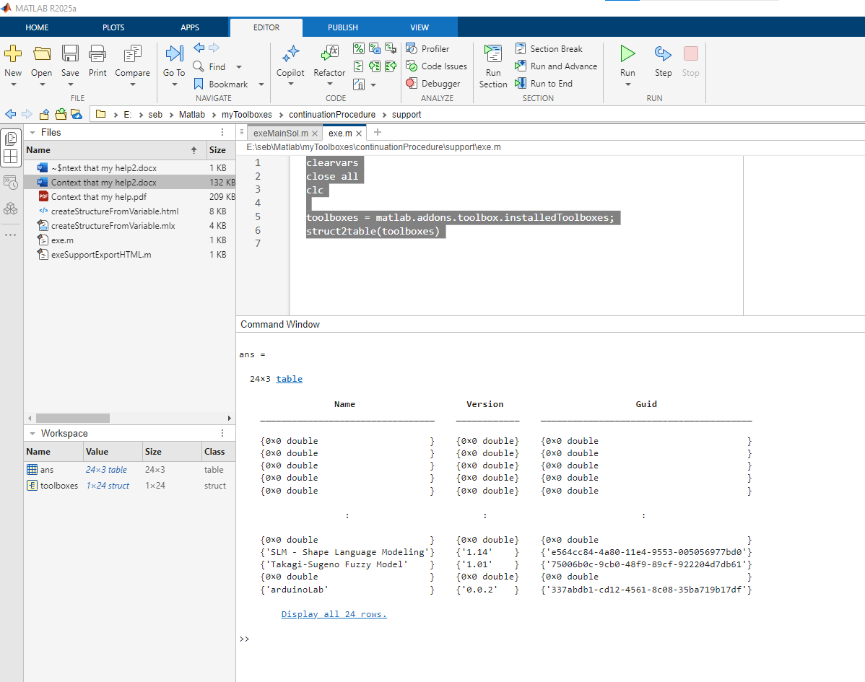

# R2024b (no pb)

Running the same code in r2024b, we can see that the fields have all non-empty values.

